CHAPTER 4: Systems — living connections
Worksheet 4.7

Bones, joints and muscles
Answers

Location of bones
1. Complete the following diagram by inserting the correct names of bones from the list below.
clavicle  humerus  femur  pelvis  sternum  tibia  vertebra  ribs  skull | 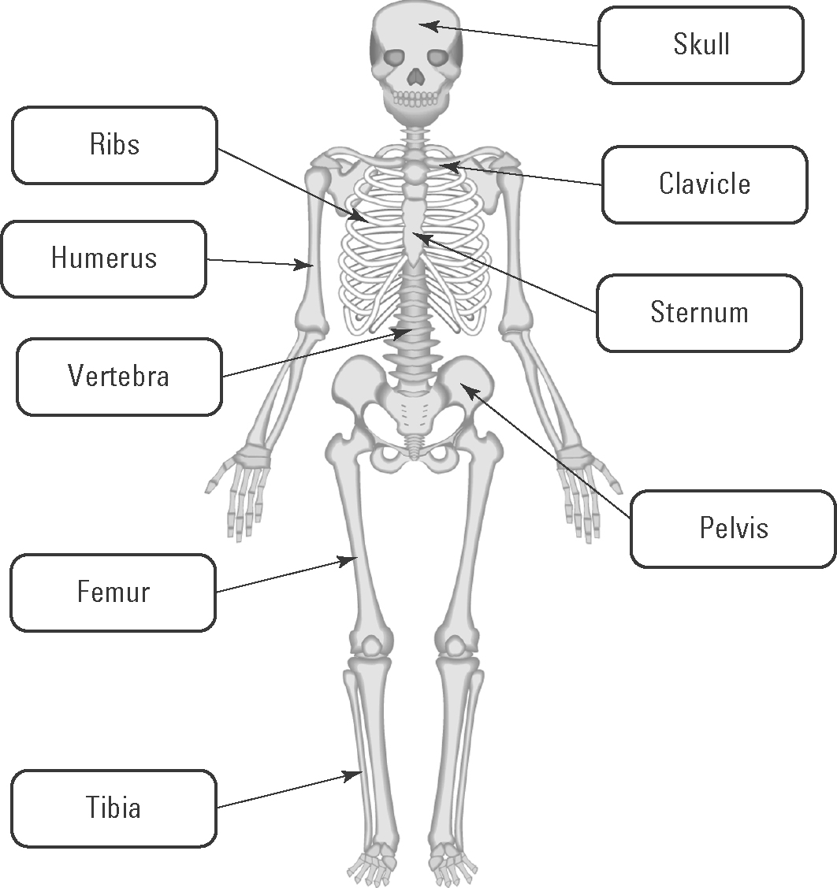

Joints
2. Complete the following table by inserting the correct term for the type of joint in the first column.
Types: hinge pivot ball and socket
Type of joint | Movement of the joint
Ball and socket | Allows movement in many different directions
Hinge | Allows movement in only one direction
Pivot | Allows twisting movements

Joints, bones and muscles
3. Consider the diagram below of the arm and shoulder.
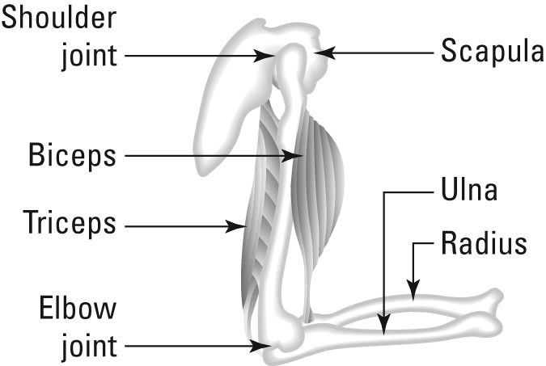 | (a) Identify the types of joints in this drawing.  Shoulder: ball and socket; elbow: hinge  (b) Explain how the forearm can be raised and lowered via the combined action of the two muscles and the elbow joint.  To raise the forearm, the biceps muscle contracts and the triceps muscle relaxes. To lower the elbow, the tricep contracts and the bicep relaxes.

